

Analog Electronics

**Assignment**

**IE2030**

|  |  |
| --- | --- |
| Title: Digital Voting System with Countdown Timer and Real-Time Vote Tally | |
| Batch Number: Y2S1  CSNE WD1 | Group Number: (WD 08) |
| Declaration:  We hold a copy of this assignment that we can produce if the original is lost or damaged.  We hereby certify that no part of this assignment has been copied from any other group’s work or from any other source. No part of this assignment has been written / produced for our group by another person except where such collaboration has been authorized by the subject lecturer/tutor concerned.  Group Members:    IT23366336 A.M.N.S.Weerarathne …………………………  signature    IT23363670 E.D.O.Samarakoon …………………………  signature  **Submitted on: <06/10/2024>** | |

Introduction

The design and implementation of the audio output section in a basic AM radio entail a unique challenge that encapsulates most of the principles of analog electronics. We shall be developing, in this assignment, a multistage amplifier-filtering circuit which processes and amplifies the weak radio signals with clarity, free from unwanted noise.  
  
The AM radios receive signals that could be hugely attenuated by many kinds of interference and noise; therefore, filtering should be performed to enhance the signal. We have three main stages in the given circuit design: a high-pass filter, a common-emitter amplifier with a BJT, and a low-pass filter. Each stage plays an important role in signal processing, including low-frequency noise removal, amplification of the desired signal, and suppression of high-frequency interference.  
This is the high-pass filter, which will reject all unwanted low-frequency components and allow only frequencies above 1 kHz to pass. This will be useful in retaining the audio signals when surrounded by noise. After filtering, the signal is forwarded to the common-emitter amplifier, which has a targeted gain of at least 50 to increase the strength of the signal to a level where it can be put to work. Finally, we are adding a low-pass filter to damp the noise at high frequency. The cutoff frequency is at 15 kHz; that smoothes the output signal for audio in reproduction.  
  
This report presents the theoretical selection of components, design decision justification, and implementation on the dot board. We further provide measurements of waveforms at key points within the circuit as part of our effort to give a more insightful look into the behavior of the signal throughout this processing chain. Testing the performance of the amplifier and effectiveness of filtering stages should show that this circuit will easily be able to provide high-quality audio output, meeting basic requirements for a simple AM radio.

|  |
| --- |
| **Acknowledgement**  We would like to express our deepest appreciation to the Sri Lanka Institute of Information Technology for providing us with the responsibility to complete this report. In addition, we would like to thank Mrs. Dinithi Pandithage, our AE lecturer who played a great role in providing the necessary guidelines to complete this report and for all the lab instructors who support us in laboratory practical. We would like to express our thanks to all the people who provided support us in finishing this project.  **Abstract**  This laboratory work involves the design and implementation of the multi-stage amplifier with filtering for the audio output of a basic AM radio. A circuit is to be designed, using Bipolar Junction Transistors and passive components on a dot board, to process and amplify weak signals from radio broadcasts so that good-quality audio output would be ensured-filtering noise and allowing only desired bands of frequencies.  The design covers three stages, namely,  High-Pass Filter: The design uses an RC filter of cutoff frequency 1 kHz to remove low-frequency noise from the signal at its input.  Common Emitter Amplifier: In this stage, a BJT in common emitter configuration is used for amplification of the filtered signal to achieve a mid-band voltage gain of at least 50.  Low-Pass Filter: A low-pass filter with a cutoff frequency of 15 kHz is designed in a way that high-frequency noise is filtered out, therefore smoothing the output audio signal.  This would include key requirements such as working out the suitable resistor and capacitor values for the filters, design of the amplifier to operate from a 9V DC power supply and ensuring a stable biasing point for the BJT amplifier. The proposed circuit will be implemented on a dot board by paying close attention to neat wiring and reliable connections.  These include: a working circuit, a report with theory and calculations, design decisions, schematics, output waveform measurements, and discussion related to the performance and effectiveness of the amplifier and filtering stages. This project thus gives an example of how the principles of electronic design can be applied to the development of a functional audio processing circuit for AM radio.  Table of Content   1. High-Pass Filter…………………………………………………………………… 7    1. Theoretical calculations……………………………………………………….. 7    2. High-Pass Filter Outputs………………………………………………………. 9 2. Transistor-Based Common Emitter Amplifier……………………………………... 11    1. Theoretical calculations……………………………………………………….. 11    2. Transistor-Based Common Emitter Amplifier Outputs………………………...12 3. Low-Pass Filter……………………………………………………………………..14    1. Theoretical calculations…………………………………………………………14    2. Low-Pass Filter Outputs………………………………………………………...15 4. The design choices for components…………………………………………………20 5. Observations and explanations of signal behavior at different stages of the circuit...22   4. Conclusion…………………………………………………………………………….25  **1 High-Pass Filter**        **Theoretical calculations**  A high-pass RC (Resistor-Capacitor) filter is an essential electronic circuit designed to allow high-frequency signals to pass while attenuating lower-frequency signals. This is particularly useful in applications where low-frequency noise or interference needs to be minimized to improve the quality of the desired signal.  Fc = 1 kHz Fc = 1 / 2ΠRC RC = 7 / 2 × 22 × 1 kHz = 1.591 × 1/10^4  Here, we used 10nF capacitor (because of cost effectiveness, versatility, reduce noise susceptibility, stable performance, easier in calculations, manageable physical size)  i.e.: To cutoff low frequency noise, we need to use a lower capacitance value.  When, C = 10nF  R = 15.91 kΩ As, R ~ 16 kΩ we used it.      103 Mylar 16 kΩ    1 High-Pass Filter Outputs    **1KHz**  **3KHz** |

**500Hz**

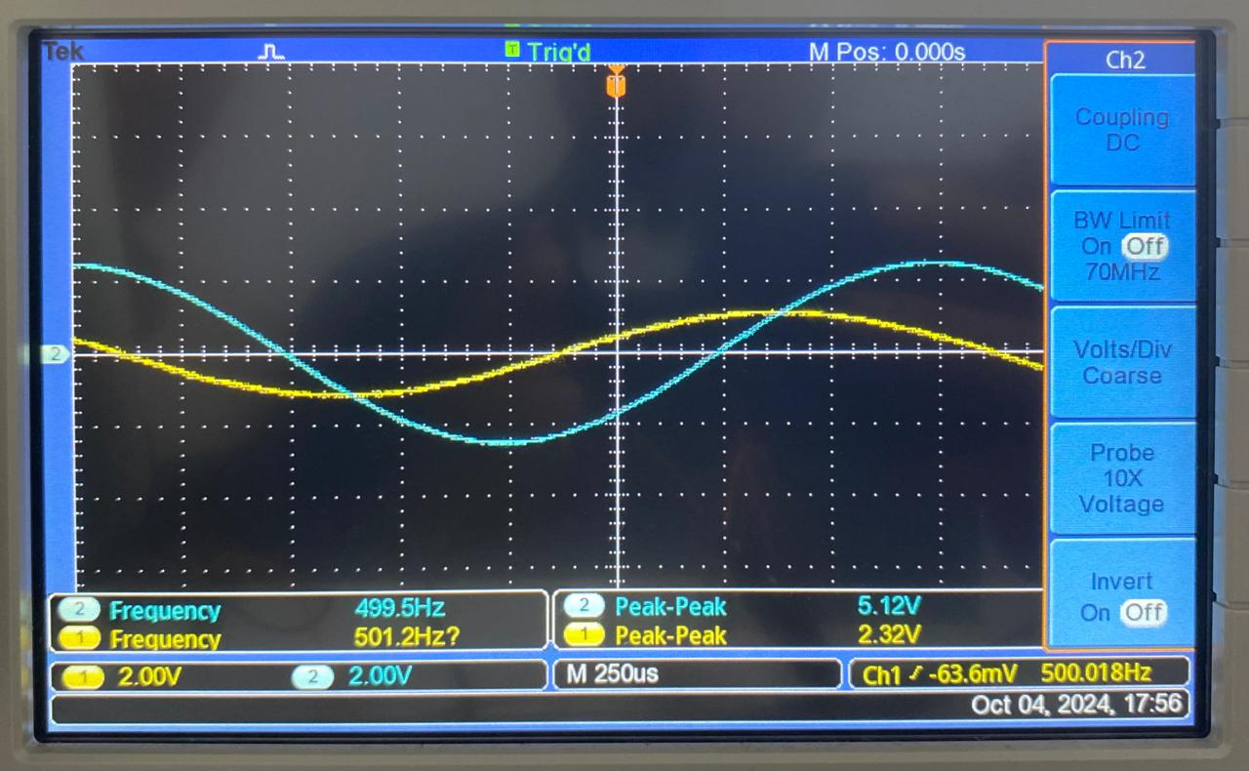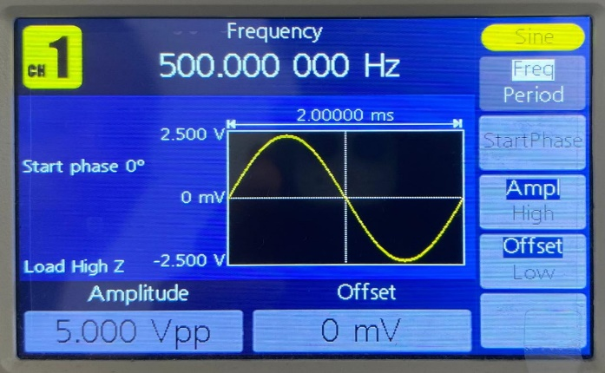

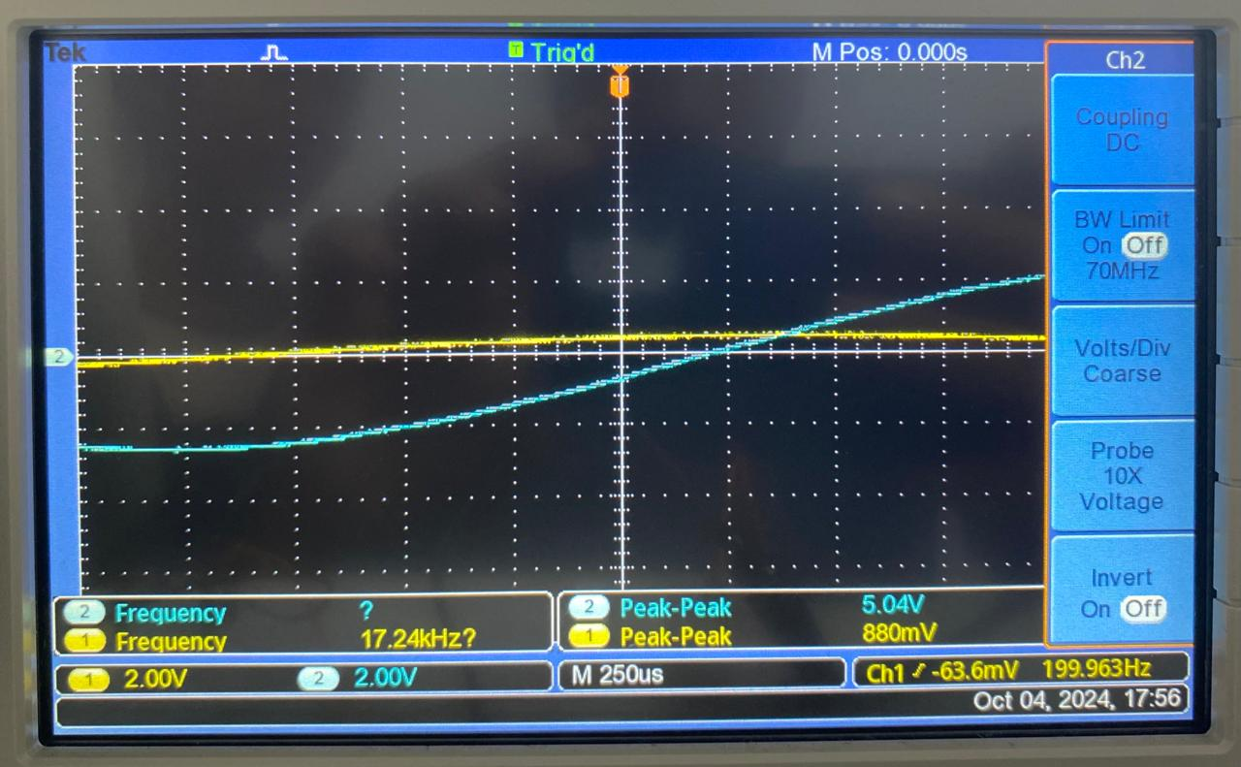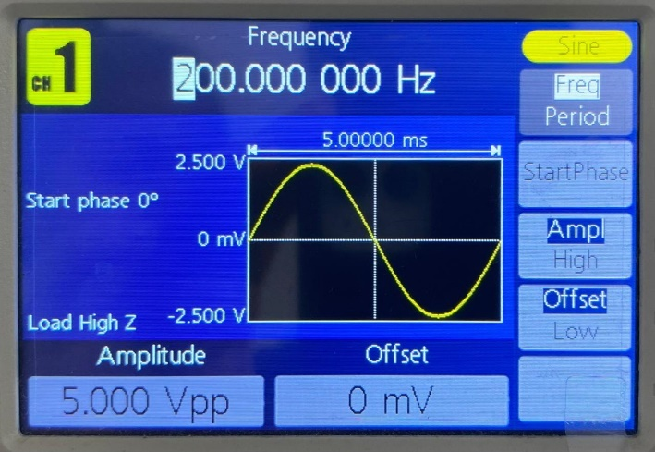**200Hz**

2. Transistor-Based Common Emitter Amplifier

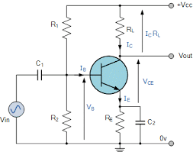

**2.1 Theoretical calculations**

A common emitter (CE) amplifier is a widely used configuration for amplifying signals in electronic circuits. In this setup, the transistor (in this case, a BC547) amplifies the input signal applied between its base and emitter, while the output is taken from the collector and emitter.

VCC = 9V

Av = RC /RE 50 = RC /RE RC = 50 RE

Assume, RE = 100 Ohms RC = 50 x 100

=5 K ohms

VE = IERE IE ~ IO  = 1 m A VE = 1m A X 100 Ohms

= 0.1V

VB = VE + VBE VB = VE + VBE

= 0.1 = 0.1 + 0.6

= 0.7 V

VB = VCC X R2

R1 + R2

0.7= 9 X R2  Assume, R1 =10 K ohms

10k +R2

R2 = 843 ohms

**For input f = 1KHz**

C1 ~ 1/2πfR1 = 1/2π x 1000 x 10K = 15.9n F

C2 ~ 1/2πfRE  = 1/2π x 1Kx 100 = 1.59µf

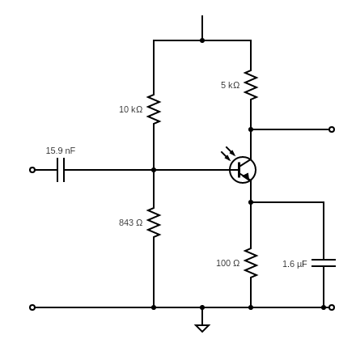

**2.2 Transistor-Based Common Emitter Amplifier output**

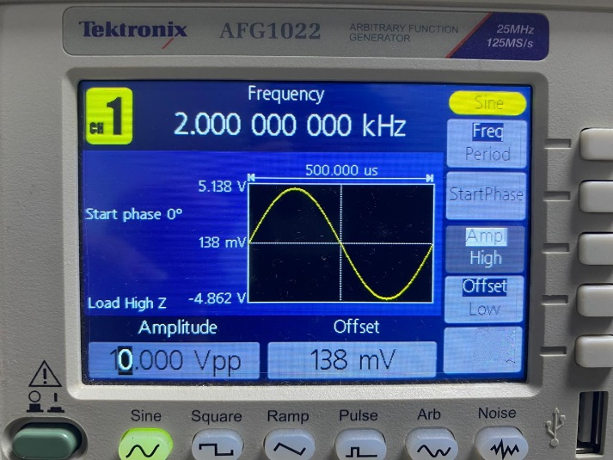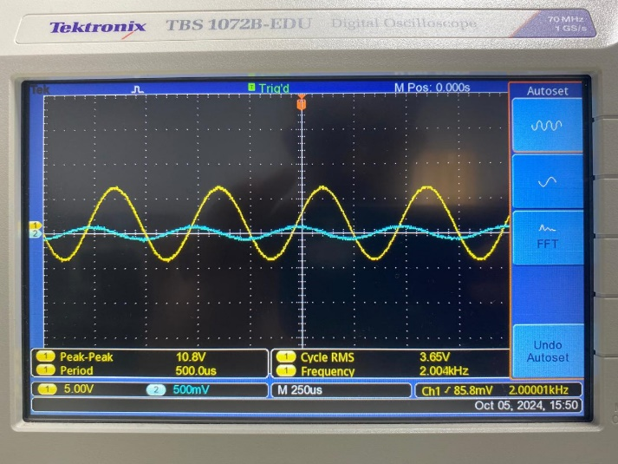

Gain = Vin ÷ Vout

Gain = 5V – 5mV = 10

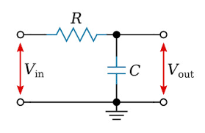 3 Low-Pass Filter

**3.1 Theoretical calculations**

A low-pass filter (LPF) is an essential electronic circuit designed to allow low-frequency signals to pass through while attenuating higher-frequency signals. This type of filter is particularly useful in audio applications, where it helps to smooth out signals by removing unwanted high-frequency noise or interference.

Fc = 15 kHz Fc = 1 / 2ΠRC RC = 7 / 2 × 22 × 15 kHz = 1.06 × 1/10^5

Here, we used 100nF capacitor (because it’s commonly available, easier in calculations, signal smoothing, noise reduction)

i.e.: To cutoff high frequency noise, we need to use a higher capacitance value.

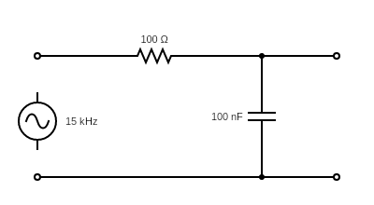

When, C = 100nF, R = 106 Ω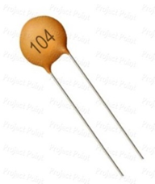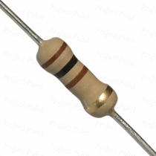 As, R ~ 100 Ω, we used it.

100Ω 100Nf

**3.2.Low-Pass Filter outputs**

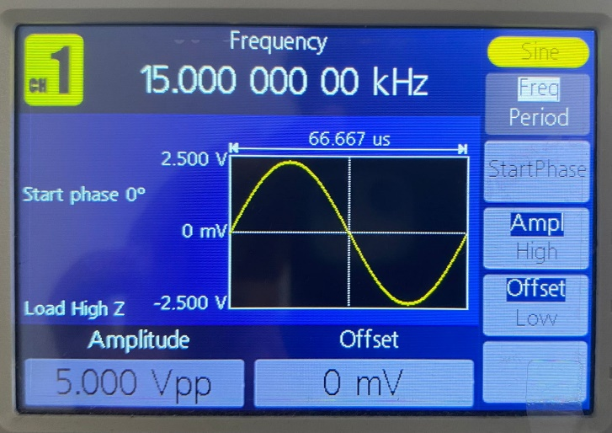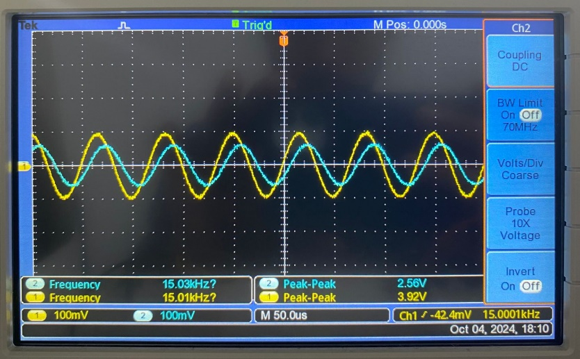**15KHz**

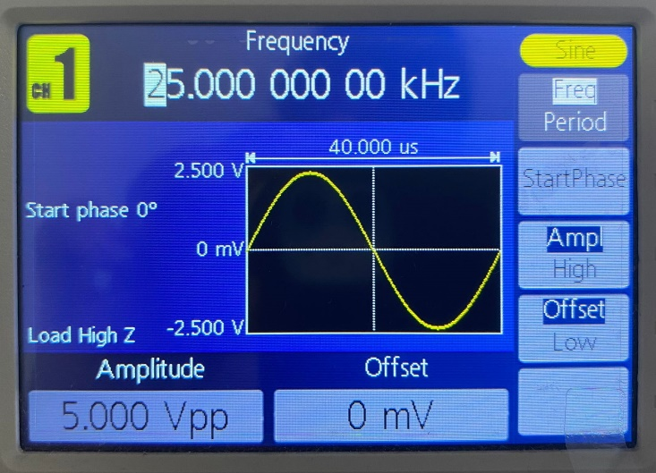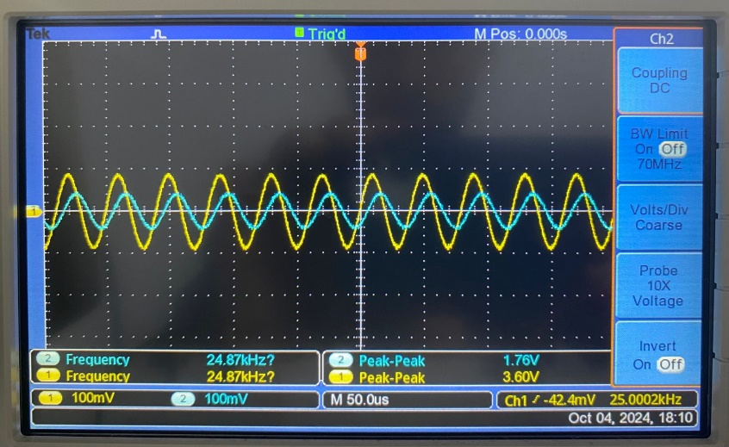**25KHz**

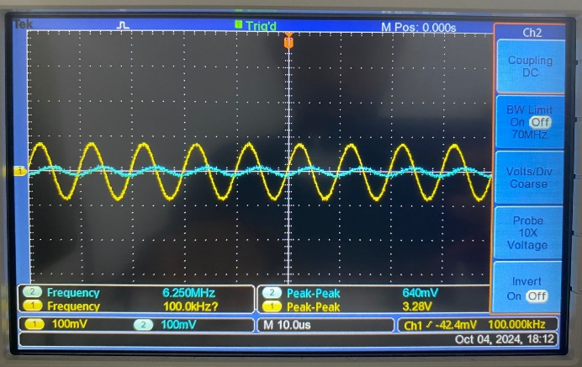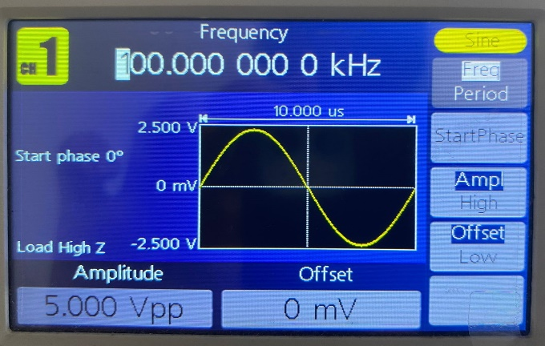**100 KHz**

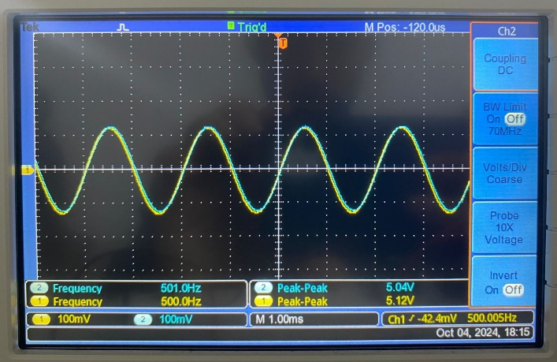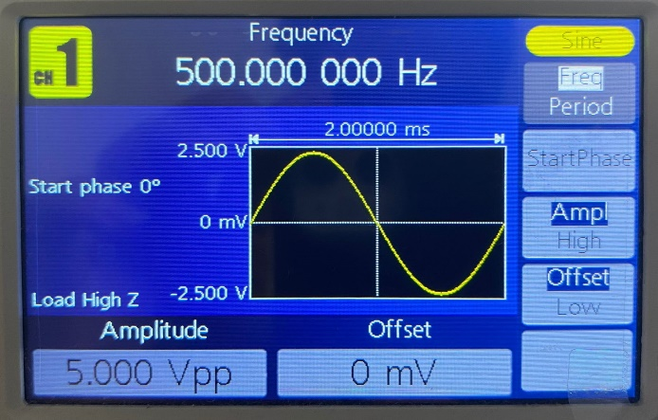**500Hz**

**100Hz**

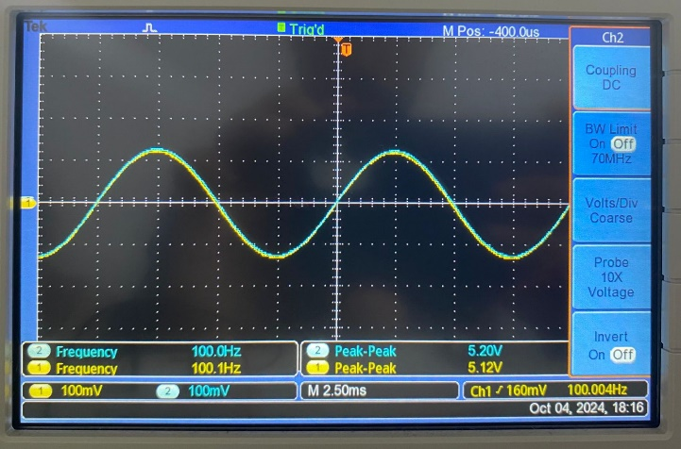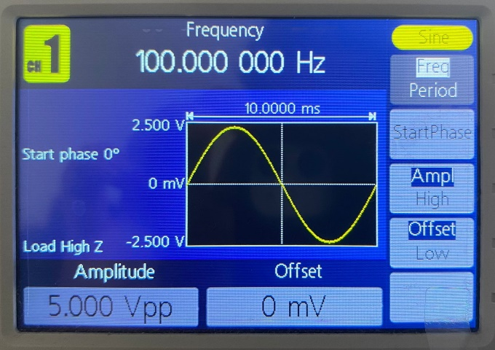

**Final Circuit**

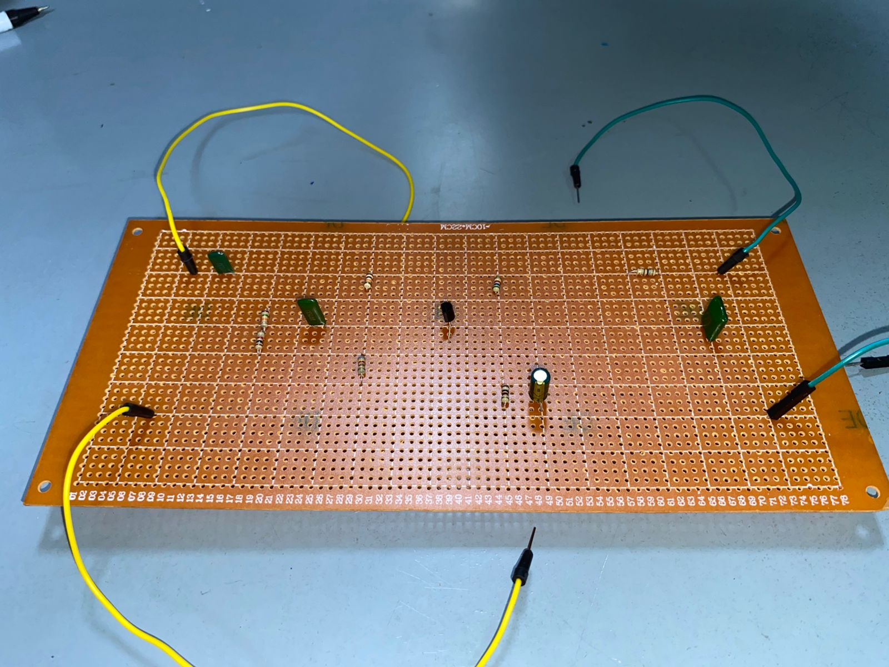

**The design choices for components.**

**Xc = 1 / 2πFC**

Here, when frequency and capacitor values decrease the capacitor resistance increases. Then, the output voltage also increases. So, we used the lowest valued capacitor for the high pass filter from the recommended range 10nF – 100nF.

For the low pass filter, we used the higher recommended value 100nF capacitor to cut off higher frequencies as when C decreases output voltage also increases according to the opposite of the above theory.

**10nF 103 Mylar capacitor / 100nF 104 Mylar capacitor**

• Commonly available

• Cost effective

• Reduce noise susceptibility

• Easier calculations

• Manageable physical size

• Stable performance

• High dielectric strength

• Low dissipation factor

• Temperature stability

• Good self-healing properties

• Compact size

When, reducing the capacitance we should use a higher resistance to get the required output.

So, we used 16kΩ resistor for our high pass filter.

As, we used a higher capacitance we should use a small resistance in order to get a higher output voltage by cutting of higher frequencies. In case, 100Ω resistor is used for the low pass filter.

**16kΩ resistor**

• Precision and stability

• Current limiting

• Noise reduction

**100Ω resistor**

• LED protection

• Lower power Dissipation

• Versatility

• Current sensing

**BC547**

* High Gain: The BC547 has a high current gain (β), typically between 100 and 800, making it suitable for amplification applications.
* Low Noise: It has a low noise figure, which is important in audio and RF applications where signal clarity is crucial.
* Moderate Frequency Response: The transistor has a maximum frequency (f_T) of around 300 MHz, which is adequate for many amplifier designs.
* Small Size: The BC547 comes in a compact package (TO-92), which is convenient for breadboarding and prototyping.
* Low Cost: It’s widely available and inexpensive, making it an economical choice for hobbyists and professionals alike.
* Robustness: The transistor can handle moderate power levels, making it reliable for various applications without requiring extensive heat management.
* Easy to Work With: It has straightforward pin configurations and characteristics, making it easier to integrate into designs.
* Versatility: The BC547 can be used in various configurations (common emitter, common collector, etc.) for different amplification needs.

**Observations and explanations of signal behavior at different stages of the circuit.**

**Step 1: High-Pass Filter**

Observation: In the case of high-pass filtering, signals at frequencies higher than the cut-off frequency of the low-frequency noise (1 kHz) are allowed to pass.

Explanation: During this stage, the capacitor will block all low-frequency signals below 1 kHz and allow higher frequency signals. The cutoff frequency is determined by a resistor coupled with a capacitor. Thus, this output signal has lower low-frequency noise, which makes the signal cleaner.

**Stage 2: Transistor-Based Common Emitter Amplifier**

Observation: The filtered signal of the high-pass filter is further amplified by the common-emitter amplifier. The amplitude of the output signal is extremely higher than the amplitude of the input signal.

Explanation: In a common emitter configuration, the BJT amplifies the input signal voltage. The general gain of the amplifier is defined by the ratio between the collector resistor Rc, to the emitter resistor Re. Since at least mid-band voltage gain of value 50 is obtained, the weak radio signals are amplified to a usable level. The biasing network will ensure the transistor operates in an active region where stable amplification will be achieved.

**Stage 3: Low-Pass Filter**

Observation: The pre-amplified signal then passed through a low-pass filter, which cut off the high frequency noise; therefore, the audio output became far smoother.

Explaination: It allows the frequency below the cut-off frequency of 15 kHz to pass through while damping out the higher frequencies. This stage further smoothes out the amplified signal by removing any high-frequency noise that might have been induced in the signal during the amplification process. The resistor-capacitor combination will be responsible for the cut-off frequency to filter out only the audio frequencies desired in the final output.

Overall, Signal Behavior

• Original Signal: Inbound signal very weak in nature and comprised of both low and high-frequency components.

• After High-Pass Filter: Noise in the lower frequency range is filtered out, leaving a cleaner signal with the higher frequencies remaining.

• After Amplifier: The cleaned signal is then passed on and highly amplified.

• After Low-Pass Filter: The high-frequency noise has filtered out, leaving behind a smooth, audible audio signal, which can then be outputted.

**Performance of the Amplifier and Effectiveness of the Filtering Stages**

Amplifier Performance

• Voltage Gain: The common-emitter amplifier stage should provide a mid-band voltage gain of at least 50. With such a high gain, the relatively very weak radio signals are raised to a level that is useful. The actual gain can be measured by comparing the amplitude of an output signal with that of the input signal.

• Bias Stability: The biasing network will ensure that the operation of a BJT is in its active region to provide stable amplification. It is the stability that gives consistent performance, preventing the transistor from entering saturation and cutoff regions that would distort the signal.

• Frequency Response: It is desired that the amplifier be able to provide a flat frequency response over the frequency range of interest, from 1 kHz to 15 kHz. This ensures that all audio frequencies are amplified equally without distortion to the original signal.

Filtering Stages Effectiveness

**High-Pass Filter (Stage 1):**

Cutoff Frequency: The frequency considered for the high-pass filter is 1 kHz in this design. This will, in effect, eliminate the low-frequency noise from the incoming signal, such as hum and other low-frequency interference.

Clarity of the Signal: With these low-frequency noises removed, the high-pass filter allows only the wanted higher frequency components of the radio signal to pass through the amplifier stage, leading to a much cleaner signal with less background noise.

**Low-Pass Filter (Stage 3):**

Cutoff Frequency: The low-pass filter is designed to have a 15 kHz cutoff frequency. It prevents high-frequency noise, such as static and other high-frequency interference, from finding their way out.

Smooth Audio Output: In removing high-frequency noise, it smoothens the output audio signal to ensure that the final audio output is clear and pleasing to listen to.

**Conclusion**

The design and implementation of a multi-stage amplifier and filtering circuit for the AM radio audio output effectively demonstrated the principles of analog electronics and the importance of signal processing. The successful integration of a high-pass filter, common-emitter amplifier, and low-pass filter enhances the clarity of weak-input radio signals while suppressing noise as much as possible. The filtering of low-frequency interference by the high-pass filter, raising the signal strength to a viable level by the common-emitter amplifier, and suppression of high-frequency noise by the low-pass filter all combine in playing their important role within the circuit to maintain high-quality audio reproduction.  
  
The detailed theoretical choice of components and justification for decisions taken regarding the design show a great understanding of the underlying concepts. The waveform measurements across key points in this circuit will be of great benefit too, as it will give the behavior of the signal across the whole chain of processing. Overall, this project is more than a minimal approach toward the requirements for a simple AM radio. This project serves as a good building block for those who may want to proceed beyond the project into the analog world of electronics and audio signal processing. The successful implementation shows that such a circuit can be used in practical applications with high-quality audio output, hence opening the possibility for further improvements of the radio principle.